**Bethel Inn Suites**

**Website Planning Document**

**Author: Miguel Angel Condorí**

**Site Purpose:** Bethel Inn & Suites is a hotel chain that builds and manages specialized hotel accommodations near temple locations of The Church of Jesus Christ of Latter-day Saints around the world. The overall goal of the website project is to promote and provide information about the specialized services that this hotel chain offers to meet the needs of temple patrons who come to serve in the temple or who participate in events such as sealings, weddings, receptions, and youth trips.

**Target Audience:**

The company serves temple workers, patrons, and their families by providing specialized services and accommodations that meet their needs. Hotel services are available to anyone who is willing to abide by the terms and policies outlined by the company.

Primarily, (1) retired people with time to perform temple ordinances and work as temple laborers; (2) families with children age 12 and older who have youth temple recommends; (3) marriages and families to be sealed; (4) friends and colleagues of the above.

**Site Map:**

Temples

Missionary

Reception

Reservation

Services

Home

**Color Scheme:**

|  |  |  |
| --- | --- | --- |
| Body | #FFFFFF |  |
| Header | #456954 |  |
| Main | #DFF0D8 |  |
| Footer | #456954 |  |
| Text | #000, #FFF |  |
| Navigation | #695454 |  |

**Typography:**

|  |  |  |
| --- | --- | --- |
| Site Header | Roboto | 40px |
| Primary Navigation | Roboto | 30px |
| Footer Navigation | Roboto | 20px |
| Heading 1 | Roboto | 30px |
| Heading 2 | Roboto | 25px |
| Heading 3 | Roboto | 20px |
| Paragraph | Monserrat regular | 16px |

**Wireframe Sketches:**

**Large view**

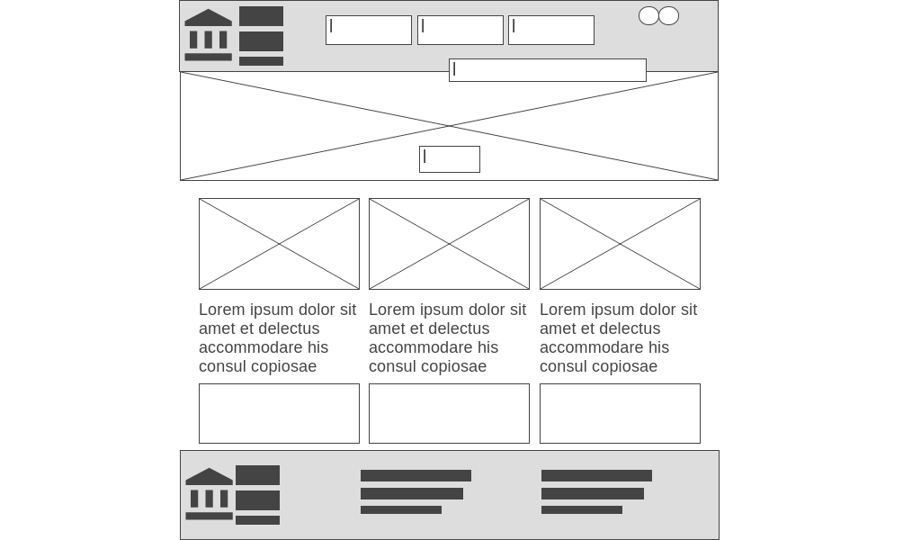

**Medium view:**

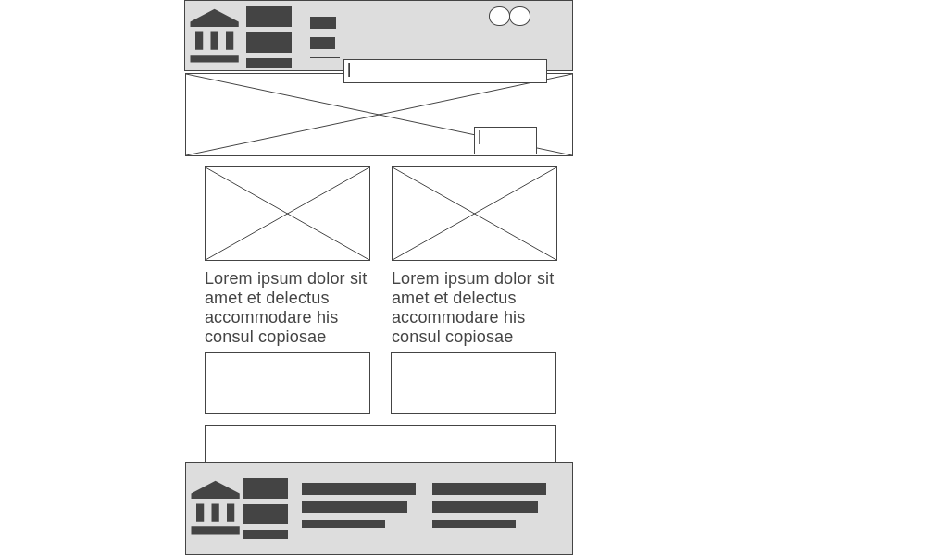

**Small view:**

